MANUAL-1

About our organisation

Kandla Special Economic Zone, popularly known as KASEZ, was the first Free Trade Zone in the country and was converted as a Special Economic Zone from November 2000. It is one of the seven Central Government run SEZs in the country. KASEZ aims at providing an internationally competitive and hassle-free environment for investment in export production.
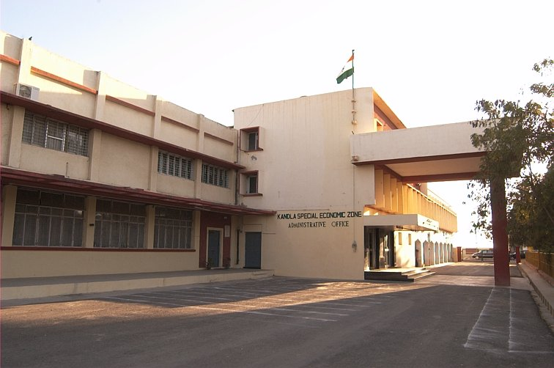

KASEZ is a subordinate office under the Ministry of Commerce & Industry, Department of Commerce, Govt. of India. Development Commissioner is the Chief Executive Officer and is responsible for guiding entrepreneurs for setting up of units in the SEZ, promotion of exports from the Zone in co-ordination with the Central & State Government Departments, monitor performance of the Developer/s and units in the SEZs in Gujarat and units under the 100% EOU scheme in Gujarat. At present there are 3 functional SEZs under the charge of Development Commissioner, KASEZ - (1) KASEZ at Kandla, (2) SurSEZ at Sachin, Surat and (3) Surat Apparel Park at Vanj, Surat. There are 240 100% EOUs currently working in 19 districts of the State under the Administrative jurisdiction of this office. To cater to the needs of the 100% EOUs set up in these locations and for co-ordination work, branch office of KASEZ is functional at 1, NBCC House, Near Sahajanand College, Ambawadi, Ahmedabad.
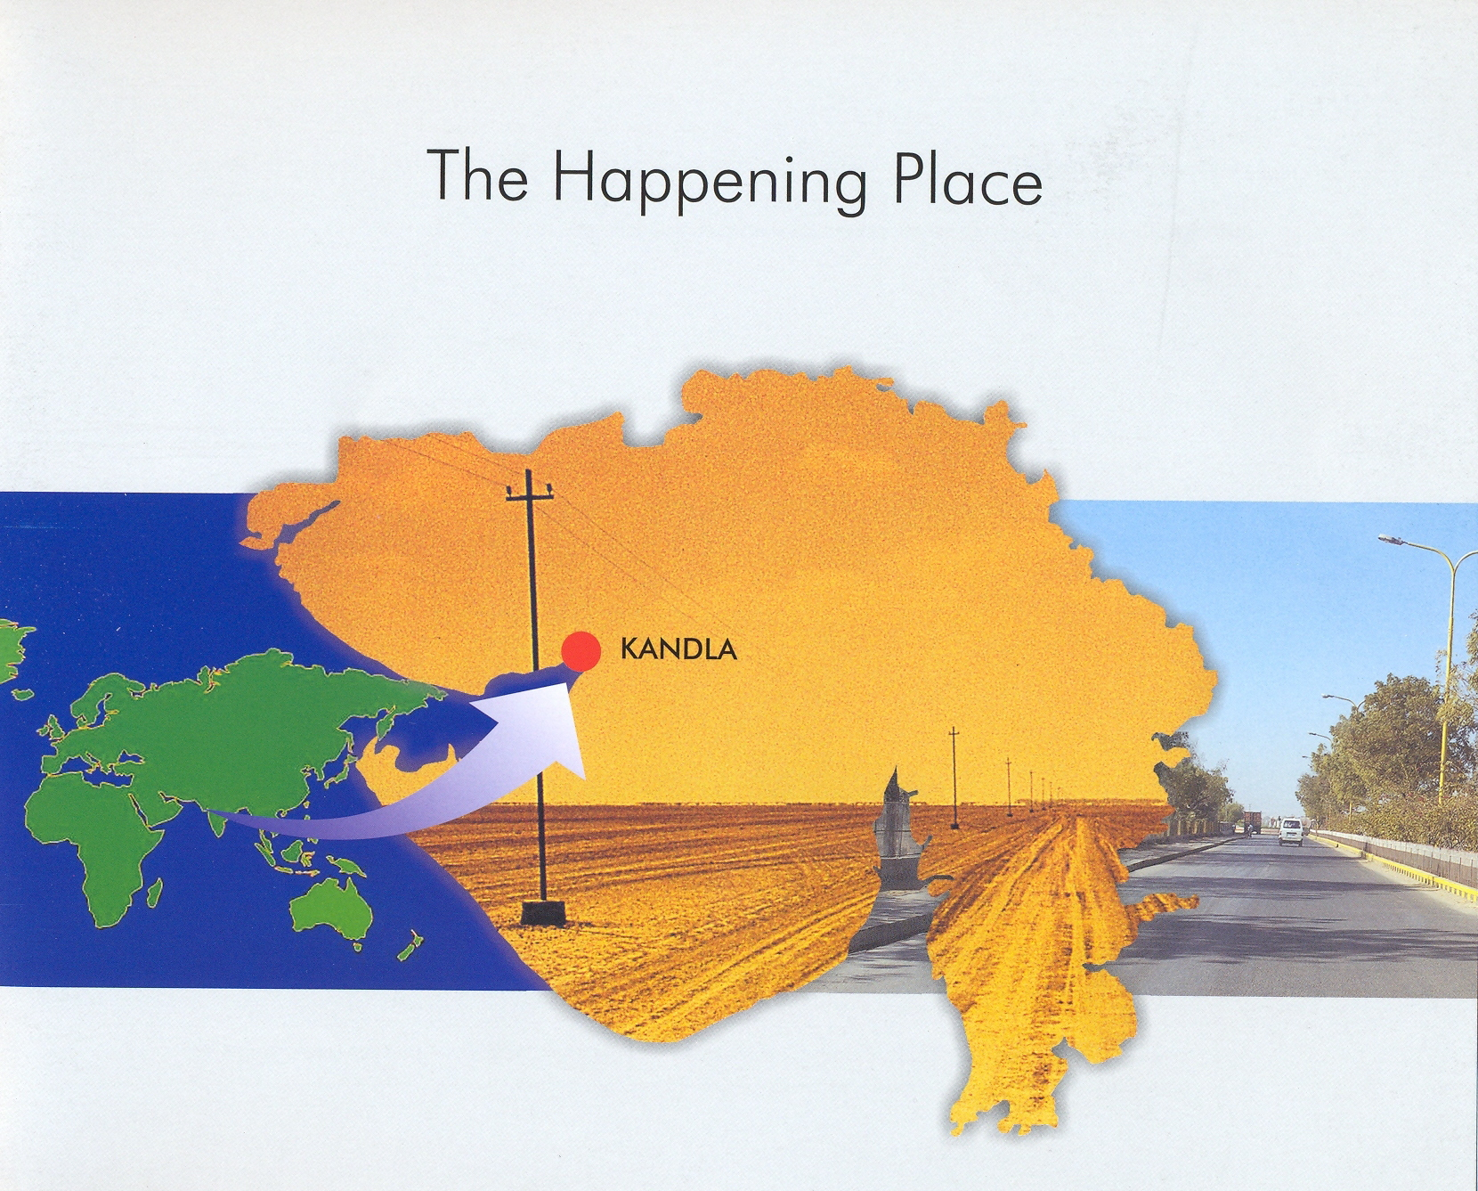
Zone Administration provides round the clock Custom services for units in KASEZ.

KASEZ provides excellent infrastructure facilities for export production - it is strategically served by two sea Ports – the next door all weather port of Kandla and the new Port at Mundra, 70 km away, with international Container Terminal facilities. The Zone is connected by excellent road and rail network. After SEZ conversion Govt. of India has spent about Rs. 28.00 crores for upgrading the internal infrastructure of KASEZ. The first Free Trade & Warehousing Zone of the country with modern infrastructure support is likely to come in the new area of the Zone under development. Further infrastructure upgradation work is in progress. Also an additional 300 acres of adjoined land has been acquired and is under development for expansion.

Office of the Development Commissioner also functions as the Licensing Authority under the Foreign Trade Policy in the District of Kutch.

