MANUAL-4

The Special Economic Zone Operations

All activities of SEZ units except as otherwise specified are on self certification basis. Units can subcontract production or part of production process outside zone. They can transfer goods to other units in the Zone without restrictions. SEZ units can import all materials required for authorized operations, without payment of duty and without the requirement of import licenses. Supplies of goods and services from the Domestic Tariff Area are treated as exports and are eligible for export benefits as applicable.
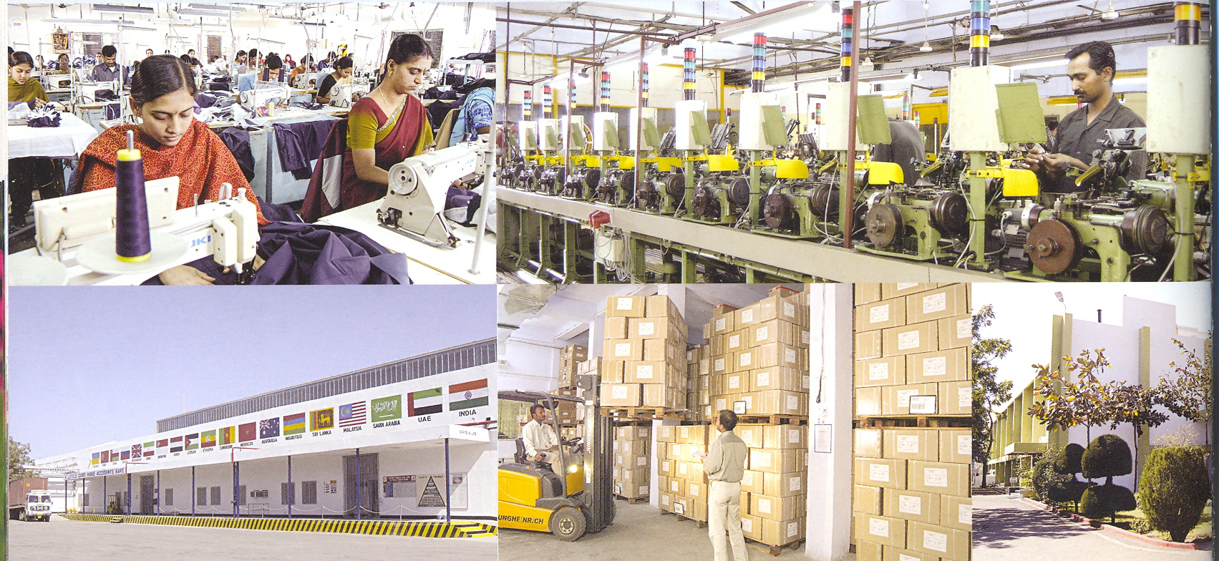

All procedural requirements for imports and exports are completed within the zone.

