**ONLINE PAYMENT OF CUSTOMS DUTY (SEZ to DTA Bill of Entry Transactions)**

**Version 1.0**

**Introduction**

Presently, the duties applicable in SEZs are paid using document challan at any of the Agency Bank branches. SEZ Online system provides detailed Challan of the duty to be paid. SEZ Unit / Buyer pays the duty at the bank and records the details of the duty payment in the system. SEZ Customs verifies the challan payment and provide “Out of Charge” for clearance of the goods. In line with the existing practice at some of the SEZs, SEZ Online also facilitates bulk payment of duty in advance which can be adjusted against Bill of Entries. Scrips / Licences issued by DGFT can also be utilised for offsetting the duty obligation.

Now, SEZ Online System is integrated with DG System, CBIC (ICEGATE) and Office of Principal CCA, CBIC and RBI to facilitate online payment of duties. Users would be able to pay the duty amount online.

This manual explains the process of Payment of Customs duty using electronic mode in case of transactions when SEZ entities (Units / Developers / Co-developers) clears goods to companies in Domestic Tariff Area (DTA), EOU, STPI etc. and SEZ Customs assess the Bill of Entry (BoE) with Duty Payment Order.

***Online Payment of Customs Duty (SEZ to DTA Transactions)***

SEZ Online System will now be enabled for Online Payment of Customs Duty in transactions where SEZ Units / Developers / Co-developers are making Supply to DTA, EOU, STPI Units etc.

As per advice of SEZ Division, Department of Commerce, Ministry of Commerce & Industry and Principal CCA CBIC, Online Duty Payment will be enabled through ICEGATE System.

***Steps for BoE processing with Online Payment of Duty:***

|  |  |  |
| --- | --- | --- |
| **Sr. No.** | **Stage of Bill of Entry** | **Remarks** |
| 1 | Bill of Entry Creation | No change |
| 2 | Bill of Entry Submission using Digital Signature |
| 3 | Bill of Entry Assessment by Customs – Challan Generation |
| 4 | Duty Payment – Options | Additional facility of Online Duty Payment would be available. When user opts for Online Payment of Customs duty, Challan will be shared by SEZ Online System with ICEGATE System. |
| 5 | Log-in to ICEGATE portal to Access Challans | Select SEZ Name, enter IEC/PAN of DTA buyer to fetch challan details on ICEGATE portal |
| 6 | Selection of Challan/s for duty payment | ICEGATE System will present all unpaid challans. Single or multiple challans (Max.10) can be selected for duty payment. |
| 7 | Generation of Mandate form | User will be presented screen to generate **“Mandate Form”.** Payment option NEFT or RTGS needs to be selected and Mandate Form needs to be generated and to be printed/saved. |
| 8 | Duty Payment | User needs to make duty payment using NEFT/RTGS mode by Quoting “Account Number”, “IFSC” mentioned in Mandate Form. NEFT / RTGS transfer can be made from any bank, using online banking or branch banking facilities offered by such bank.  **Note:** Net banking will enabled in due course. |
| 9 | Updation of Duty Payment at ICEGATE and in SEZ Online | All NEFT / RTGS Transfers will be made directly to duty collection account of Principal CCA. This account is maintained at RBI. Upon receipt of money, RBI will provide electronic confirmation to ICEGATE. In turn, ICEGATE will provide confirmation to SEZ Online. |
| 10 | Verification of Duty Payment and Out of Charge | When Success payment message is received from ICEGATE, Bill of Entry transaction will automatically be moved to Customs (PO) inbox for “Out of Charge”. |

***Process of Payment of Customs Duty with Screens is detailed below:***

Presently online duty payment facility is enabled for SEZ to DTA, EOU, STPI etc. Bill of Entry Transactions.

1. **Creation of Bill of Entry and Submission of Bill of Entry:**

There is no change in preparation and submission of Bill of Entry through SEZ Online System.

1. **Assessment of Bill of Entry:**

There is no change in assessment of Bill of Entry by SEZ Customs. When duty is payable, it will be assessed with any of the below status.

1. **Approved with Duty:**
2. **Approved with Duty (GST)**:
3. **Approved with Duty (Provisional)**:
4. **Approved with Duty (GST)(Provisional)**
5. **Final Assessment Completed – Pay Duty**

When any of the above status is marked by Customs, Facility for Online Duty payment will be enabled for selection. In case, part of the duty is adjusted against any DGFT Scrip, only balance portion would be applicable for online challan.

1. **Option of Online Payment of Customs Duty (SEZ Online System)**

After assessment, as per the current practice, the BoE will be made available in the Inbox of the Unit for paying the duty and recording the details.

1. Entire amount due can be paid using any one of the available payment options i.e. Online Duty Payment / Bank Challan / ADL. However, after few days of implementation and monitoring of online payment facility, all other payment options will be disabled.
2. To make online payment, user need to indicate “Online duty payment confirmation” within 3 days of assessment of the transaction.
3. Once online duty payment is selected, offline payment option would be disabled for the underlying transaction.
4. Once online duty payment is selected, duty payment needs to be completed within 5 days of assessment by SEZ Customs, else the online challan will expire.

**Online duty payment option needs to be selected as below:**

* 1. **Online Duty Payment Confirmation by SEZ Entity Maker/Approver/CHA Users:**

SEZ Unit/Developer/Co-developer Maker, Approver or CHA Users have to access below link:

Link Online Duty Payment >> Duty Payment. 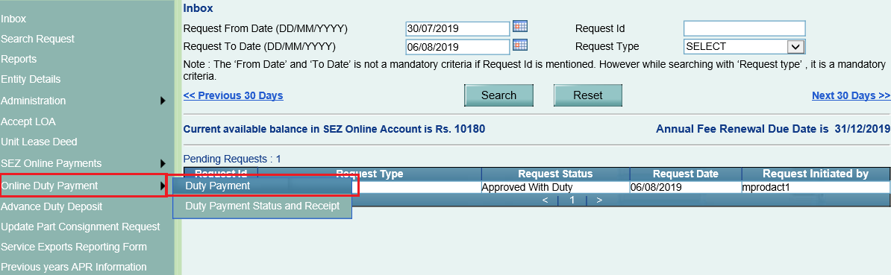

Transaction for which Duty is to be paid, Transaction Request ID needs to be entered:

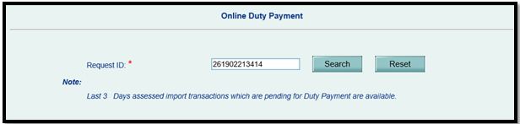

After entering Request ID and clicking on Search button, below transaction information and payment instructions will be displayed:

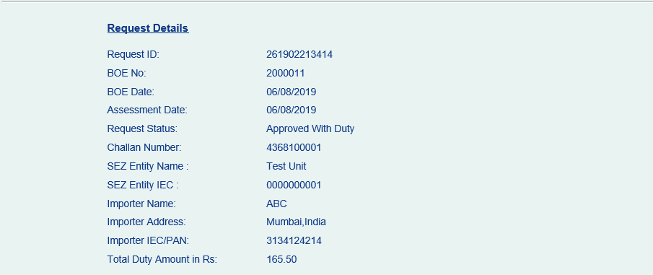

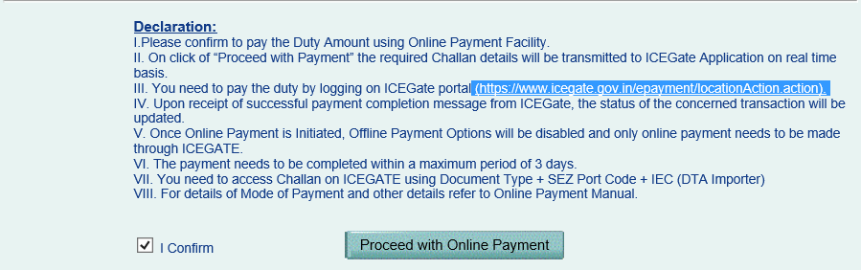

Please **Read** the instructions under **Declaration** Section and **Confirm** the same to proceed with Duty Payment.

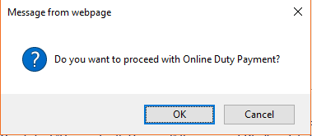

**NOTE:** Kindly note that facility for confirmation of online payment will be available for 3 days (72 hours) from date of Assessment (i.e. if it is approved by customs on 1st July 2020 at 3:05 PM, it will be available for online payment till 4th July 2020, 3:05 PM). If Online Payment option is not selected through System, payment will have to be made through TR-6 challan at agency bank branch.

Once Online Duty Payment option is selected, Challan Information will be shared with ICEGATE System. Challan will be available for payment on ICEGATE portal for 5 days from date of assessment of Bill of Entry in SEZ Online System. It means if transaction is approved in SEZ Online System on 1st July, 2020 (7:45 PM) then user will get option to opt for online duty payment till 4th July 2020(7:45 PM) and challan will remain valid in ICEGATE system till 6th July 2020 (7:45 PM).

When challan information is shared with ICEGATE and successfully accepted, below message indicating sharing of Duty Challan Information with ICEGATE will be displayed.



If there is any error from ICEGATE System then SEZ Online System will throw an error as below:

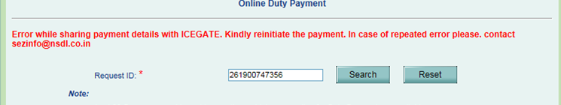

In case of error in sending Challan to ICEGATE, User will be able to select option for Online Duty Payment again and process will repeat. Users are requested to access ICEGATE site only after confirmation of sharing of SEZ BoE Challan.

* 1. **Online Duty Payment through Login Page by DTA Buyer (without Login):**

SEZ Online System also facilitates DTA companies which want to initiate confirmation of online duty payment, such DTA users can access SEZ Online System Login Page (<https://www.sezonline-ndml.co.in/User/Login.aspx>) and pass key parameters to fetch Bill of Entry information and provide confirmation as shown below:

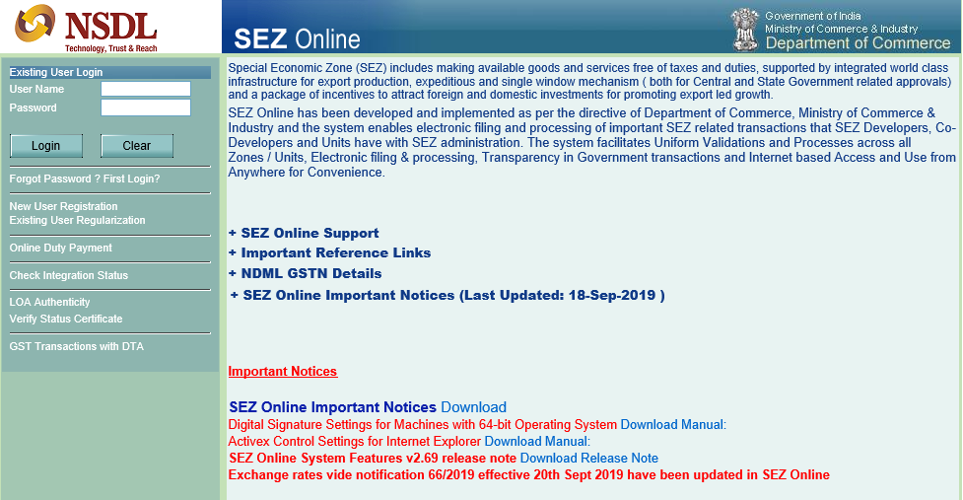

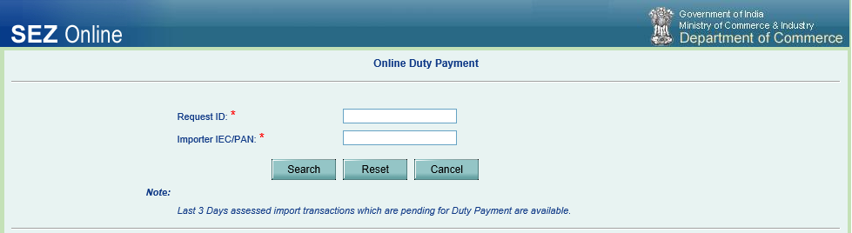

Request ID of SEZ Online DTA Sale Bill of Entry transaction and IEC/PAN needs to be captured to fetch the information. Upon reviewing information below confirmation can be provided. After confirmation is provided, Information will be presented as below:

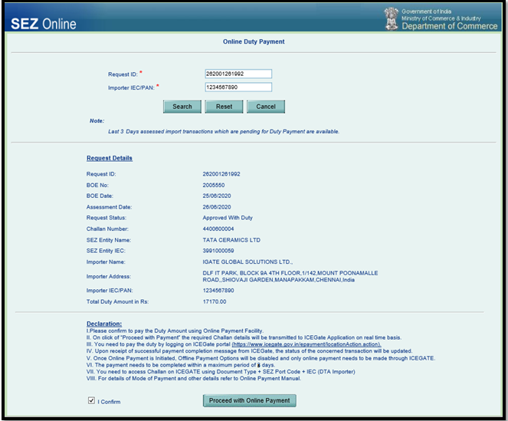

1. **Generation of Duty Payment “Mandate Form” and Duty Payment using NEFT / RTGS**

After confirmation is provided on SEZ Online portal, visit ICEGATE portal (https://cbicpay.icegate.gov.in/iceepay/) to proceed with Online Payment of Customs duty. Select Duty Type as SEZ Customs Duty, Document Type as SDTA, select Location as SEZ Name, and enter IEC/PAN of DTA buyer to fetch challans on ICEGATE portal.

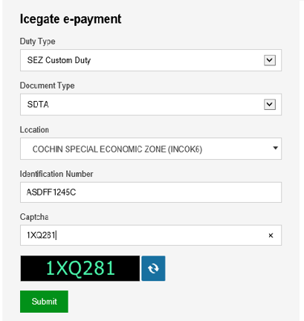

ICEGATE System will validate above details and present all unpaid valid Challans as below:

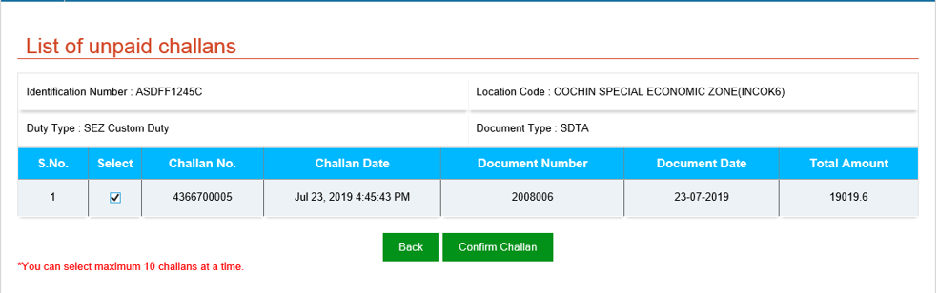

User needs to select the Challan (s) and click on “Confirm Challan” to proceed with Payment. Maximum 10 Challans can be selected & paid in Single attempt. If more than One Challan is selected, system will present list of selected Challans:

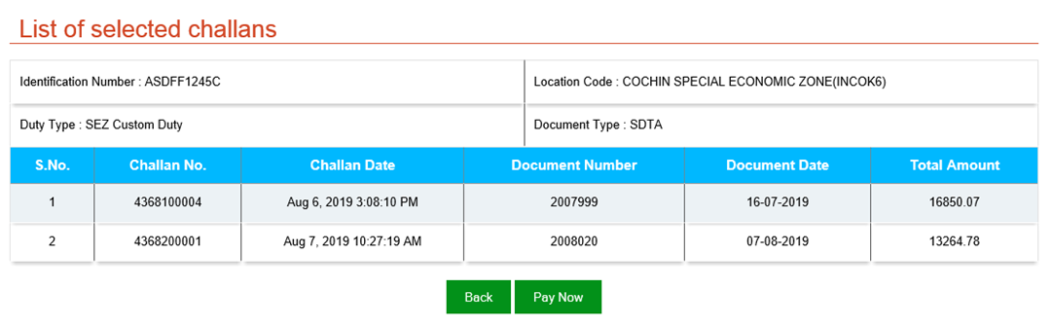

User can review the same and click on **“Pay Now”** to proceed or “Back” to go back to previous screen.Below Screen will be presented:

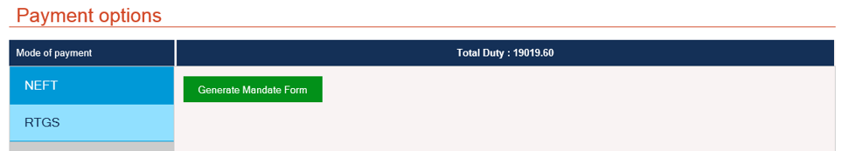

You can select the mode of payment i.e. NEFT or RTGS. The mode selected here, should only be used for making payment. Click on **“Generate Mandate Form”** and system will generate following form:

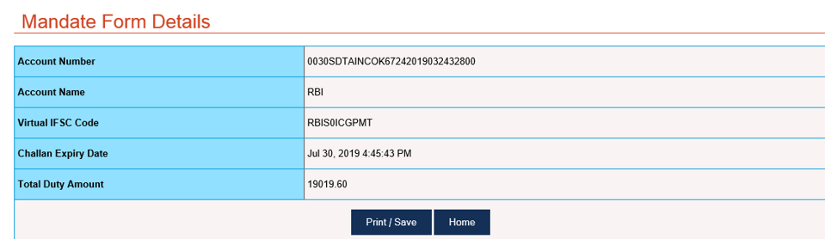

**Important Points to be noted here:**

1. Transfer can be made from any bank participating in NEFT / RTGS System.
2. The payment is being managed through RBI account and therefore the IFSC Code belongs to RBI directly.
3. The account number generated on the mandate form is a Virtual Account Number and will vary / change for each transaction and cannot be re-used.
4. ***Absolute care should be taken to ensure that IFSC Code and Account Number, as are provided on the mandate form are correctly captured in funds transfer instruction.***
5. It is suggested to Print and also save a copy of the mandate form as generated from ICEGATE system for future reference.
6. Payment must be completed (including multiple levels of authorisation) well before the expiry date and time indicated on the mandate form.
7. NEFT / RTGS transaction reference number received from your banker may be maintained for further reference.
8. In case where multiple challans are selected for consolidated payment, the duty amount would be total of all challans.

**Note:** Facility for payment using Net banking would be introduced in due course and will be intimated to all users.

1. **Confirmation of Duty Payment**

After duty is paid, RBI will validate the same against the Challan details received from ICEGATE and send confirmation to ICEGATE. ICEGATE will send confirmation message to SEZ Online System. Upon receipt of **Success** message, transaction status will be updated to reflect duty payment and will be automatically presented in Inbox of SEZ Customs for issuance of “Out of Charge”. SEZ Customs will be able to view paymentinformation as shown below:

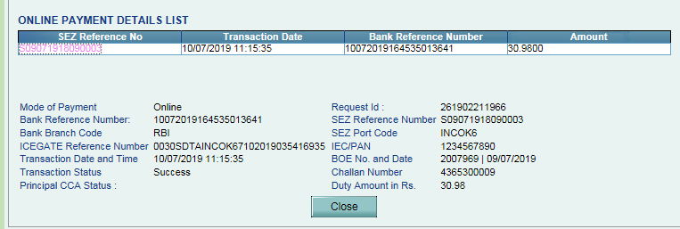

1. **Facility for Checking Status of Online Duty Payment:**

To check status of Duty Paid Online, status can be viewed by clicking on link **“Duty Payment Status & Receipt”.** User can input any of the field above to fetch information of Duty Payments made on ICEGATE portal. User can provide the input and fetch necessary information by clicking on Search.

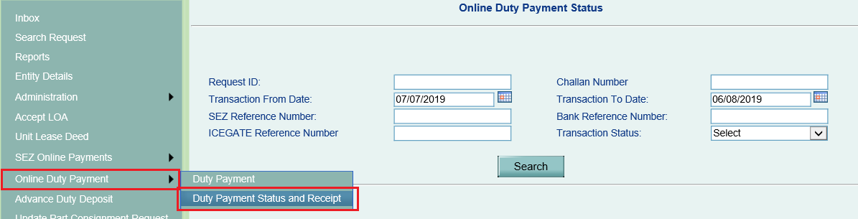

Users can fetch status by providing below parameters as Input:

* **Request ID:** SEZ Online Request ID
* **Transaction From Date & To Date:** Bill of Entry Submission Date range
* **Challan Number:** Challan number generated by SEZ Online System
* **Transaction Status:** Option are available “Pending” & “Success”

**Status will be shown as below:**

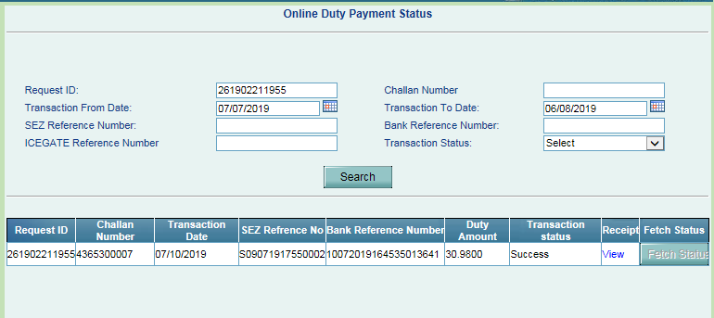

If Success message is not received the system will show status as “Pending”. However, if as per your records, payment has been successfully completed and the payment status is pending even though 60 minutes or more have lapsed, user can click on **“Fetch Status”** button to fetch real time status from ICEGATE System.

In case it is still not updated, please contact your bank or ICEGATE help-desk at :[**icegatehelpdesk**@**icegate**.gov.in](mailto:icegatehelpdesk@icegate.gov.in)) or to SEZ Online team at [Sezinfo@nsdl.co.in](mailto:Sezinfo@nsdl.co.in) . Status of Challan Paid through ICEGATE System can be viewed on ICEGATE portal also using link <https://cbicpay.icegate.gov.in/iceepay/enquiry> .

**Important instructions for Online Payment of Customs Duty:**

* **Timelines for Online Payment of Customs Duty:** Online Duty Payment Confirmation needs to be provided within 3 (72 hours) days of assessment by SEZ Customs and duty needs to paid using ICEGATE portal within five days (120 hours) of assessment. When Online Payment of Customs Duty is confirmed & challan information is shared with ICEGATE, section to enter TR-6 information for physical duty payment will be disabled.

However, if Online Duty Payment confirmation period or period of payment through ICEGATE portal expires without successful payment, then duty needs to be paid at designated bank branch through TR-6 challan. In such cases, facility to record TR-6 challan information as per current process will be enabled again.

* **Adherence to details on Mandate Form:** Please ensure that details mentioned on Mandate Form generated at ICEGATE system in respect of Account Number, IFSC, Validity date are strictly adhered to.
* **Transactions with Provisional Assessment:** When provisionally assessed BoE is presented for final assessment and if it results in increase in duty then user will get an option of payment using online duty payment facility and process explained above for online duty payment will apply.
* **Amendment of Transactions:** If amendment leads to increase in duty amount, additional duty needs to be paid at branch using TR-6 Challan. Facility for payment of such additional duty Online will be introduced in later phase of implementation.
* **Refund of duty:** If amendment / cancellation / finalisation results in decrease in duty then existing procedures for claiming refund needs to be followed and there will be no procedure for online refund through SEZ Online System.
* **Facility for Advance Duty Payment:** Facility for Payment using Advance Duty will be disabled once online payment module gets streamlined and in consultation with DoC and Principal CCA.